**COMP2119 Programming Assignment 1**

**Name: JAIN RAJAT  
UID: 3035453684**

**Class: 2B**

**Description of Environment used for the programming assignment:**

Language Used: Python

Version: 3.7 (It is important to use Python 3).

Dependencies and Libraries for the program:

* **Numpy**

In f3, the library numpy is used for matrix multiplication and the matrices are treated as numpy arrays.

To install numpy, run this command on the terminal:

pip install numpy

pip is the package manager in python and comes pre-installed with python.

Running the Python Programs:

As python is an interpreted language, it does not produce executables. One can simply run the programs by running the source code files. Instructions:

To test f1, run the following command on the terminal:

python f1.py

The result will be displayed on the screen as well as stored in the output file. It is required that the input file namely input1.txt in this case, must be in the same directory as f1.py. The output file namely output1.txt would also be saved in the same directory.

The other algorithms f2.py and f3.py can be tested in the same way.

This part of the programming assignment has been solved using the time and matplotlib libraries in python. The implementation can be found in the main.py file.

The matploylib.pyplot library is used for plotting graphs with ease.

The time libray has been used to calculate execution times for each input.

**Question 1.**

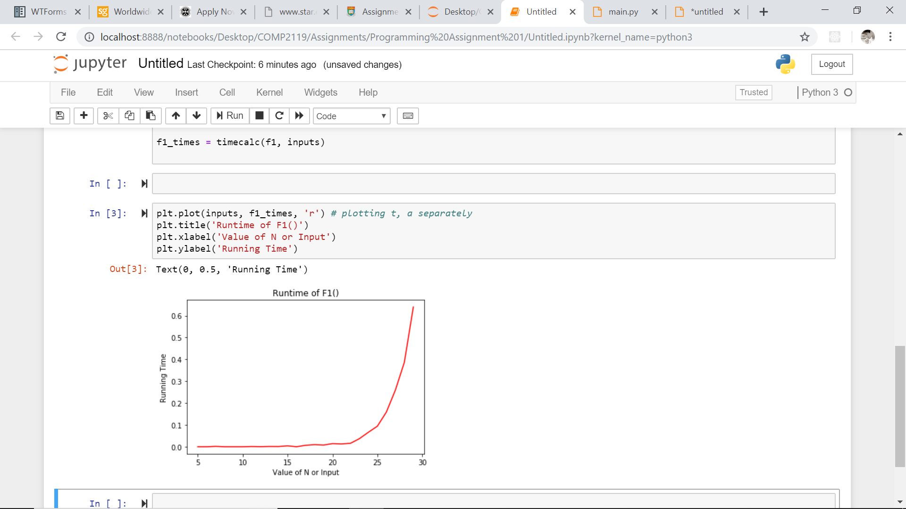

It is observed that we get an exponential graph. This was an expected result as we computed the Fibonacci numbers using the recursion approach which follows O(2n) complexity.

**Question 2.**

In the resultant graph, we can observe that F2’s graph seems linear while F3’s plot seems logarithmic. This was the expected result as the algorithm F2 follows O(n) complexity, while F3 follows O(logn) time complexity.

